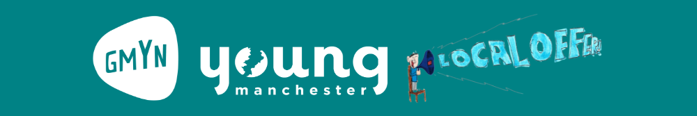
SEND Local Offer Youth Led Grants
Section 1
Organisation name
Organisation Logo
Contact name
Contact email
Contact phone

How have young people informed the activities in this proposal?
Total budget
Budget breakdown

Section 2
The information in this part of the application will be shared with young people, who will decide which projects to fund. Use clear and accessible language and short sentences where possible.
We may convert the information provided into other accessible formats (e.g. Easy Read).

Sum up your project in 3 bullet points (max 50 word)

What activities do you want to deliver?

When will you deliver these activities?

Tell us the frequency and length of sessions, and the dates these will take place.

Where will you deliver these activities?

Who will these activities be for?

Tell us the age range of children and young people, and if these activities are suitable for families to attend.

What areas of young people’s lives will your activities make a difference to?

Consider social isolation, mental health and well being, travel confidence and any other areas this project will impact.

Send your completed application form to applications@youngmanchester.org

You can contact us with any questions before you apply:
- By email at r.garbutt@youngmanchester.org
- By phone on 0161 631 2879 or 07593 558198
- By text on 07593 558198

